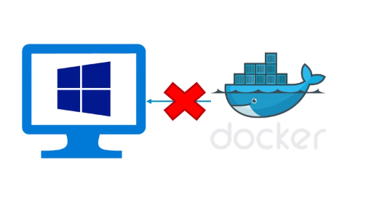

Docker uses features of Linux which windows don’t support. 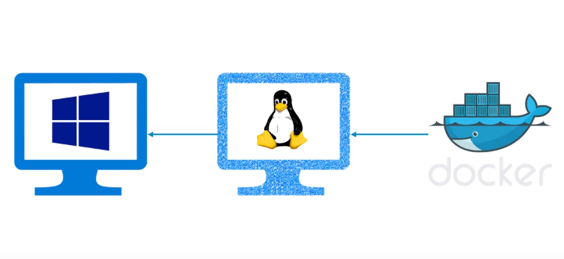

Therefore we need a virtual machine running linux and your docker will run on that VM, and windows can control it.

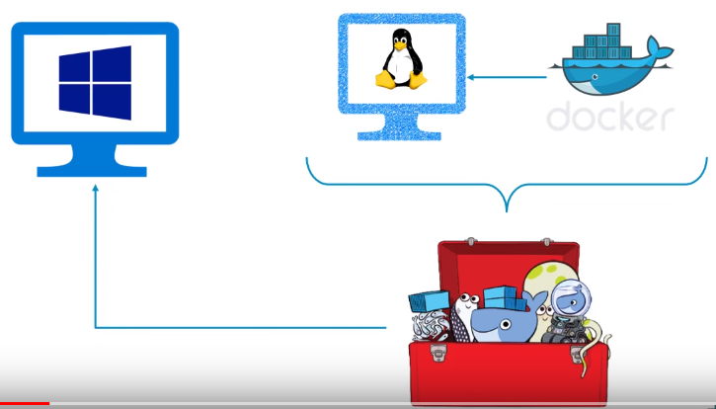

Therefore Docker guys prepared **Docker Toolbox** which takes care of this infrastructure.

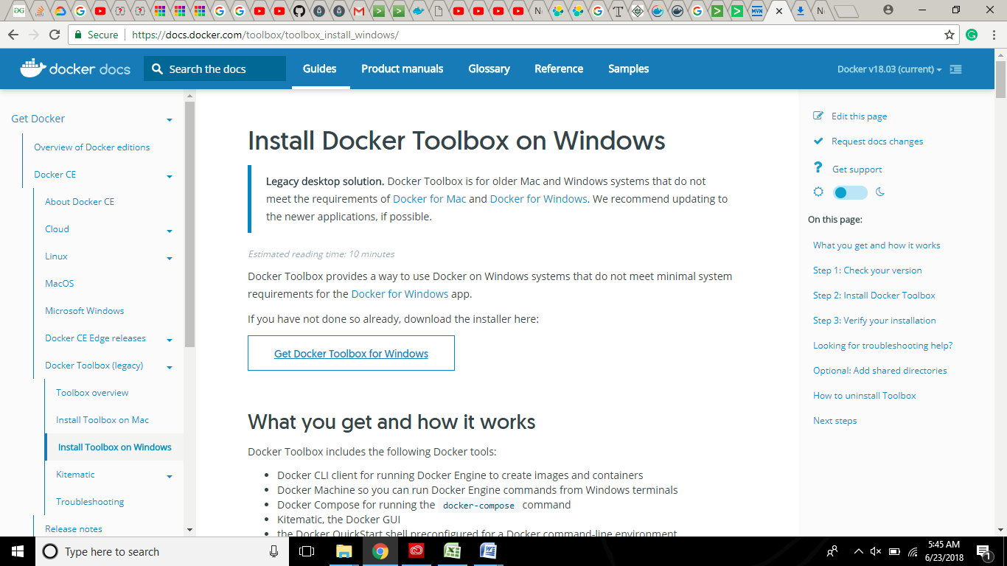

When we install Docker Toolbox these Environmental Variables get automatically set !

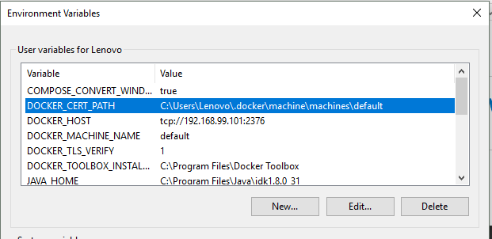

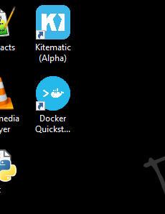

Click on docker Quickstart

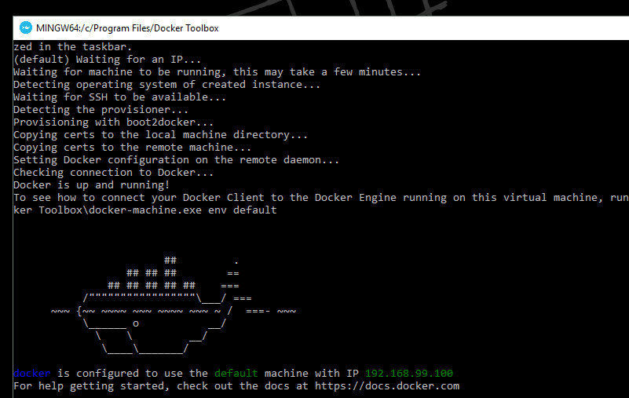

**Also notice:**

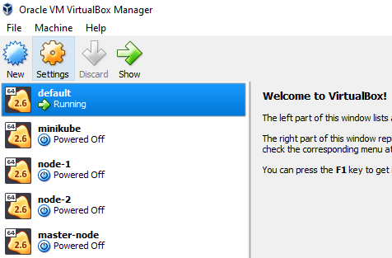

Now, let’s see steps to Dockerize Hello World Java application:

Create a folder and keep two files into it – Hellodocker.java + Dockerfile

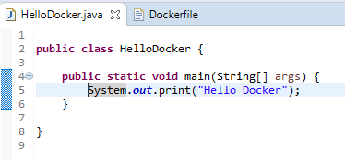

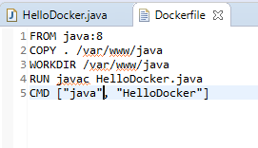

Navigate till the folder, where these files are kept [**In Docker Quickstart Terminal**]…



Verify:

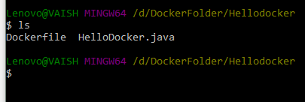

Now, execute the below commands:

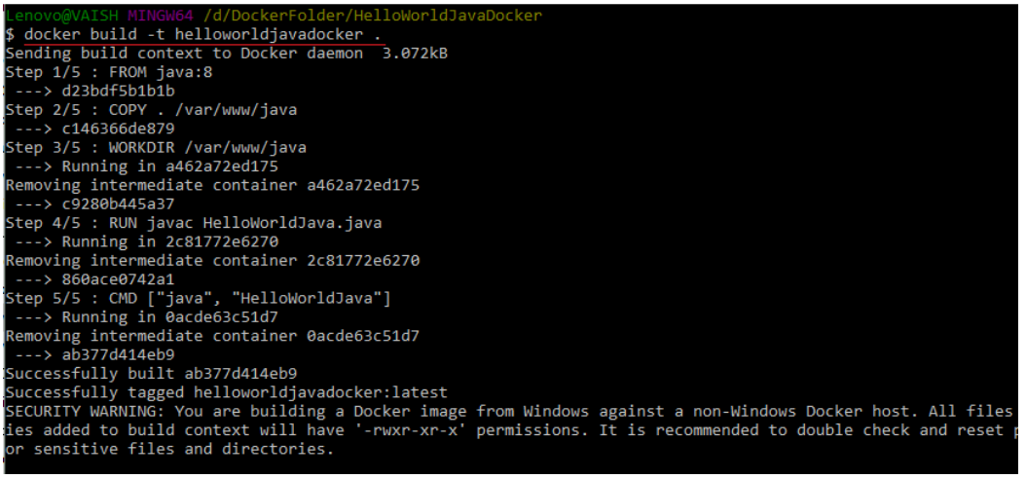

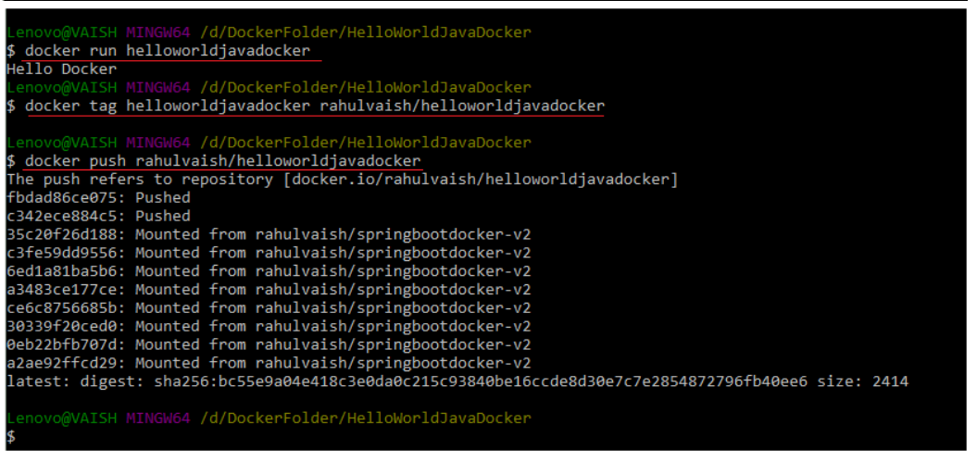

Now, if we check the HUB !!!

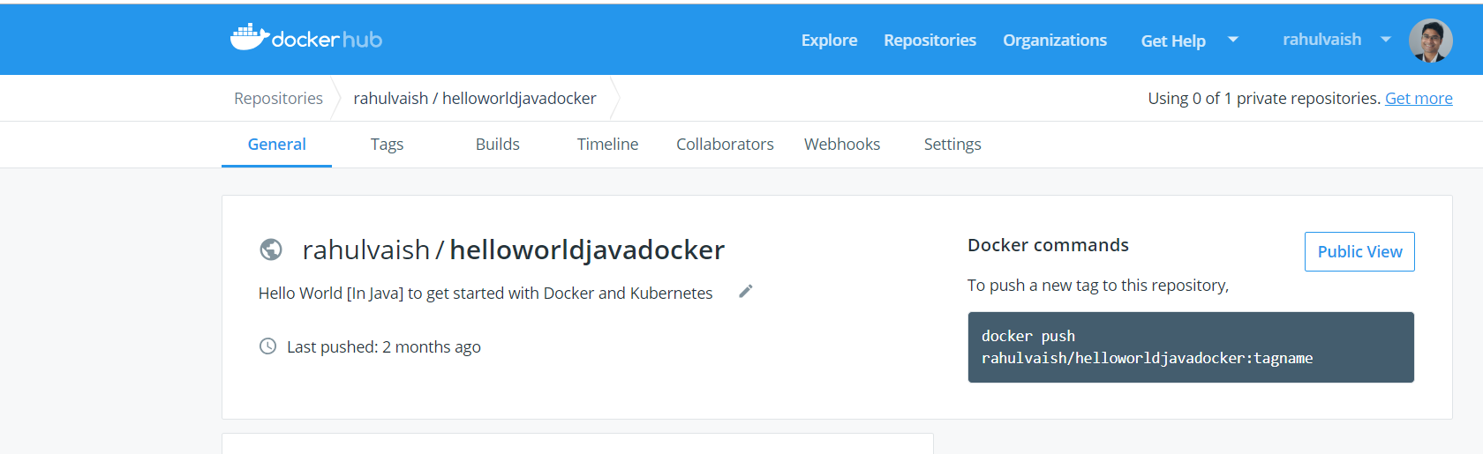

Next time, if you want to use HelloDocker, its easy:

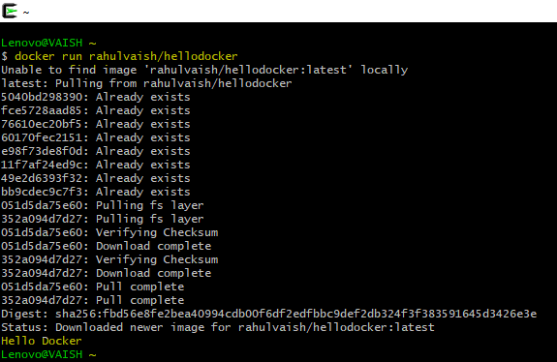

**Additional Miscellaneous Information:**

Note: In the Docker Toolbox, you will find an image (an .iso file) called boot2docker. We can use this .iso image in our VMWare ☺

However,

